Project Report



1. **Introduction**
   1. **Overview**:

Our topic is Techpro Solution that maintains financial reports of our company with combination with legal companies and maintains billings of the companys with their expenses incurred.

* 1. **Purpose**:

The purpose of this project is to maintain the financial reports of the company and their sales order with their purchase order and maintain their profits and losses.

1. **Problem definition and design thinking**:
   1. **Emapthy map**:

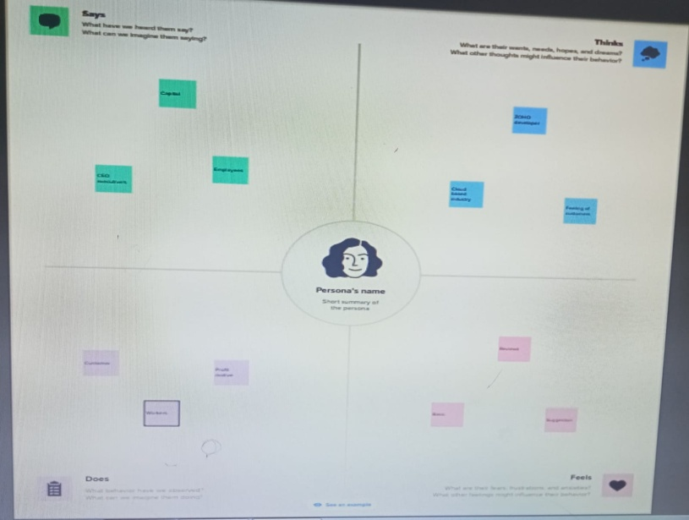

* 1. **Ideation and brain storming map**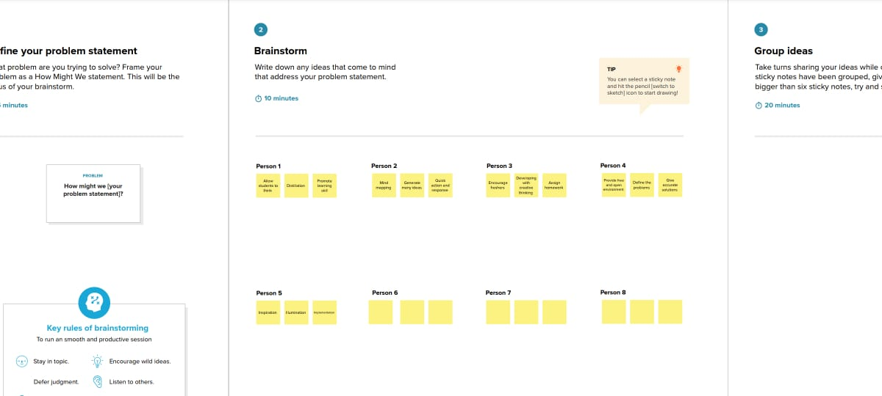

3. **Result**:

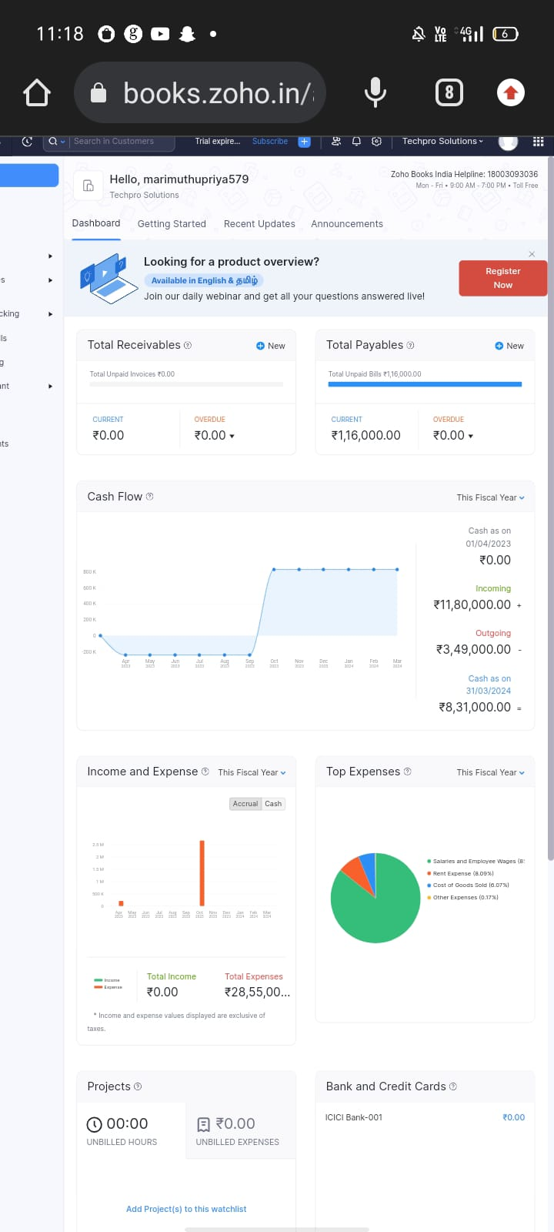

4.**Advantages and Disadvantages** :

**Advantages** :

* It helps to maintain the financial reports of the company
* It maintains bills and expenses of the company

**Disadvantages**:

* Requires better creative employees
* Risks are involved with creativity

5. **Applications**:

This software can be used for maintain the financial reports of the company and also helps to maintain the files of the company.

6. **Conclusion**:

We had made this project with the help of Zoho books and had made it perfectly with this software.

7. **Future scope**:

In future we had made a plan to meet up with best partners and provide better price planning to the customers.